Homework 3 Quantitative machine learning

A. the most preferable model is one with a 3,2 hidden layer structure with a l1 of .05.

output:  and



B: there are 10 input nodes and 1 output node.

Output: 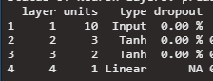

C: There are 44 biases and weights in the optimal model.

Output: 

D: the activiation function for the output layer is linear

Output: 

E: Output: 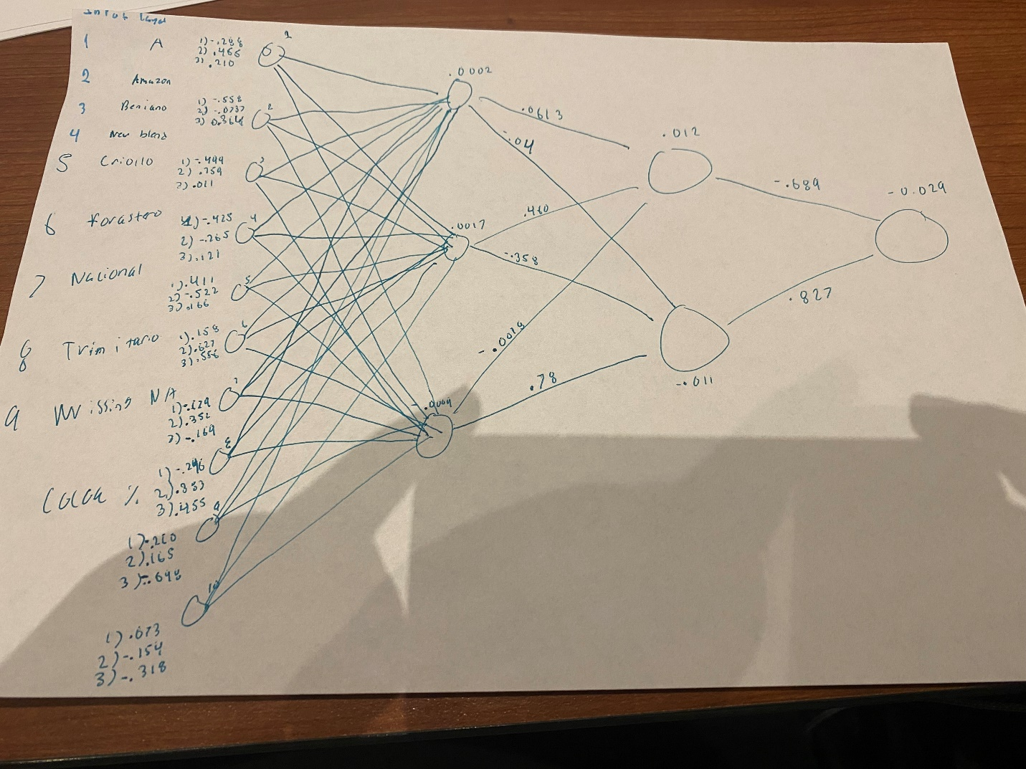

adsf

F: the mape of our model is 13.81. this means that for each prediction our model is off about 13.81 percent from the true value.

Output: 

G: our prediction for row 240 is 3.227 and lime says that it has an explanation fit of .77 or that our model accounts for 77% of what we see in row 240, therefore we should have an error of .23 or 23%.

Output: 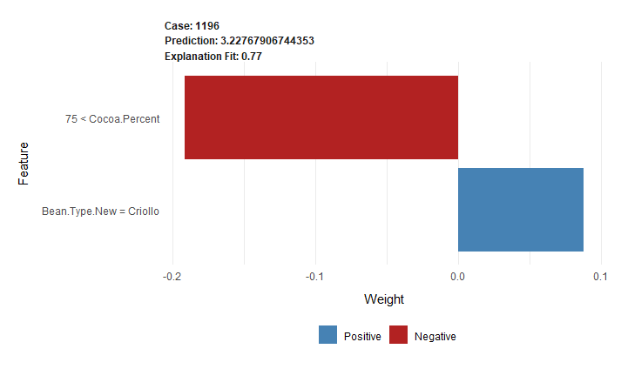

H: the reason this chocolate is getting this prediction is the brand of chocolate due to the brand of the bean type used in creating the chocolate bar, however it the percentage of cocoa is too low to be considered a high quality chocolate. Criollo chocolate is a positive effect as it is native to south America and only comprises 3% of global chocolate sales, it is a very high quality and in demand chocolate.

Output: 